RESUME
JILU MOL M J  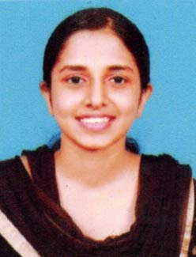  Address for Communication:  JILU MOL M J  MAMPARAMBIL HOUSE  VILLOONNI P.O  KOTTAYAM  KERALA  686008  Email:  Jiujimmy95521@gmail.com  Phone No:  Mob: +918281350128  Res: +919447507140  Personal Data:  Date of Birth : 17/06/1998  Sex : Female  Nationality : Indian  Marital Status : Single | Career Objective  - To obtain a position as Lab Technologist with utilizing relevant Knowledge gained from education and experience in a hospital laboratory atmosphere.  - To obtain a challenging job with responsibilities where I can best utilize my professional capability.  Education  - BSc MEDICAL LABORATORY TECHNOLOGIST.  From Kerala university of Health Science Thrissur.  Curriculum Project  Mini Project: Isolation and identification of pathogenic organisms from paper currency.  Professional Experiences  • Worked as a graduate trainee in DDRC SRL Ernakulam for six month Currently working as Modern Diagnostic Center Kottayam  Experimental learning  - Undergone 1 month clinical posting in MAGJ Hospital Mookkannoor, Angamaly in Biochemistry, Microbiology, Clinical pathology.  - Undergone 2 weeks posting in Regional Blood Transfusion Centre, District Hospital, Aluva.  - Undergone 1 month posting in Malabar Cancer Centre Kannur in Cytology, Histopathology and Cytogenetics, Microbiology, Biochemistry, Clinical pathology
Personal Traits

Observative skill, Patience, Understanding, Friendly, Good oral and written Communication, Positive attitude, Sincerity, Punctuality.

Hobbies :

- Travelling.
- Listening songs.
- Cooking.
- Reading

Education Details :

Course | Board/University | Institute | % of Marks | Year
BSc MLT | Kerala university of health science Thrissur | Lisieux College Of Paramedical Sciences, Mookkannoor | 69% | 2016-2020
Higher Secondary | Kerala State | Govt. medical college higher secondary school ,Medical college | 76% | 2015-2016
SSLC | Kerala State | ST.Philominas girls high school , Arpookara | 81% | 2014

Personal Profile :

Name : jilU MOL M J
DOB : 17June 1998
Gender : Female
Marital Status : Single
Name of Father : Jimmy Joseph
Nationality : Indian
Languages : English Malayalam
Permanent Address : Jilu mol M j
Mamparambil House
Villoonni p.o
Kottayam
Kerala
PIN:686008

Correspondence : jilujimmy95521@gmail.com

+918281350128, +919447507140

Declaration

I hereby declare that all the information furnished above is true to the best of my knowledge and belief.
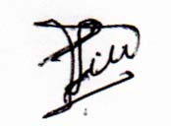

Date :
Place : Kottayam JILU MOL M J

